Optical motion sensors
The sensors to measure the position of the sphere are two PCB boards based on the Avago Technologies ADNS-2610 [1] optical flow sensor and extracted from the Logitech M-SBF96 PS2 computer mouse [2]. This sensor presents high reliability for speeds under 30.5 cm/s. Also has a register that outputs the SQUAL value, a reference of the quality of the surface. This makes the calibration process more simple.
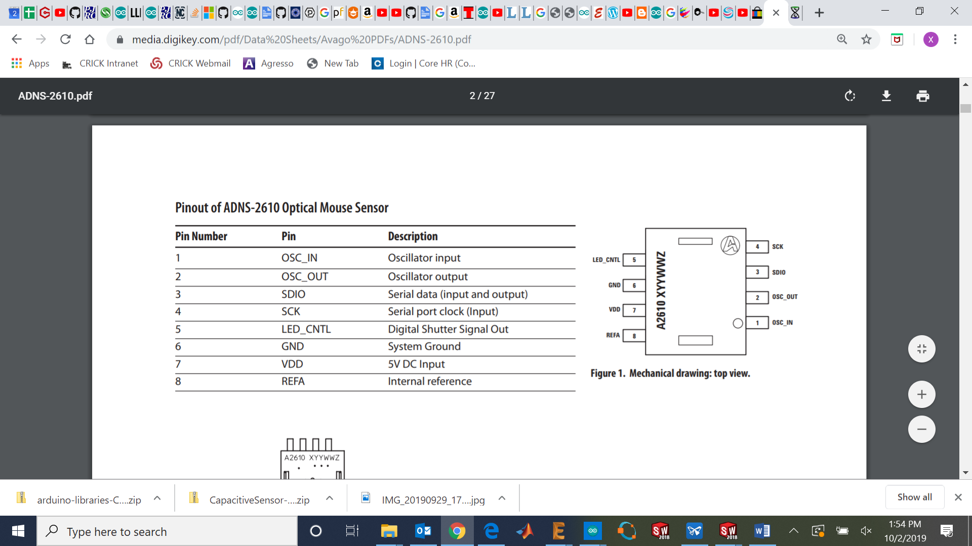
Figure 1: Pinout of the ADNS-2610 [1].
The PCB and the lens are attached to a 3D printable structure which can achieve horizontal and vertical displacements with reliability and resolution of 0.01 mm. The displacements are regulated with two micrometers with a 13 mm range (RS Components 785-7875).
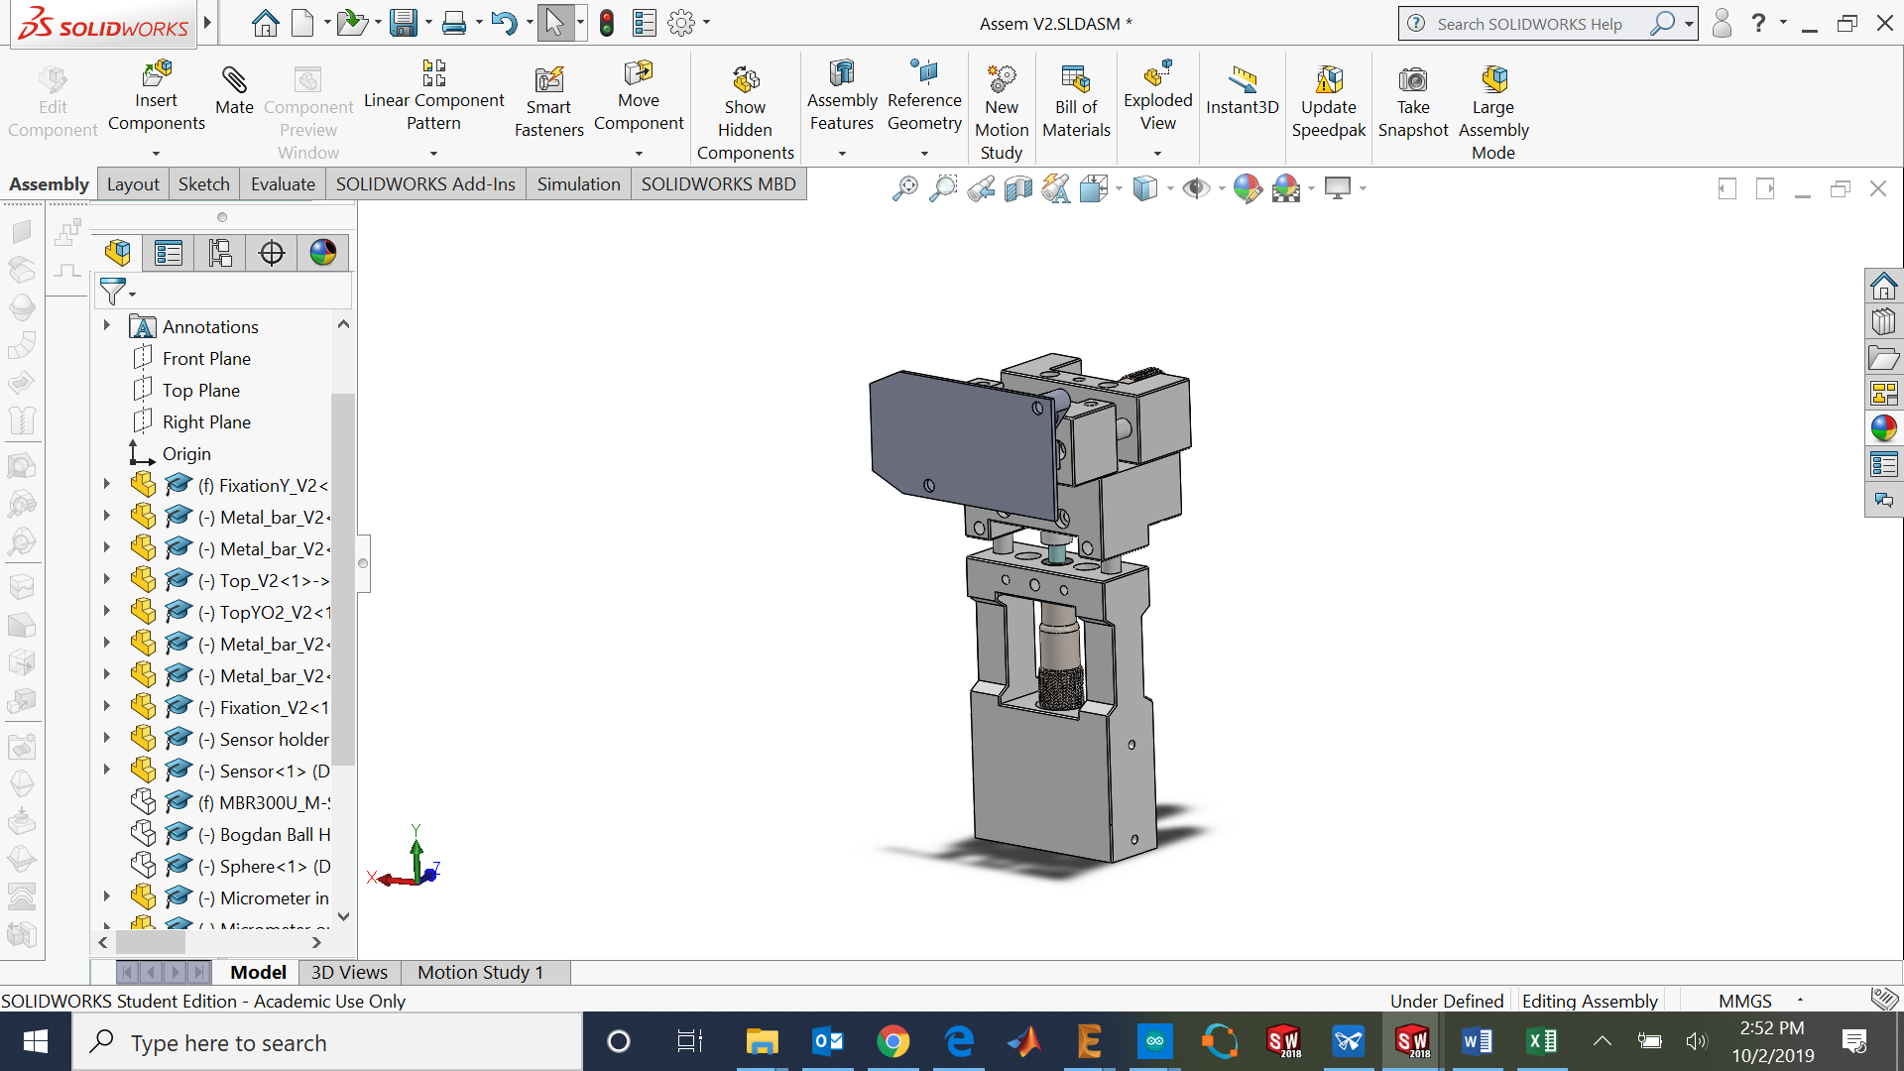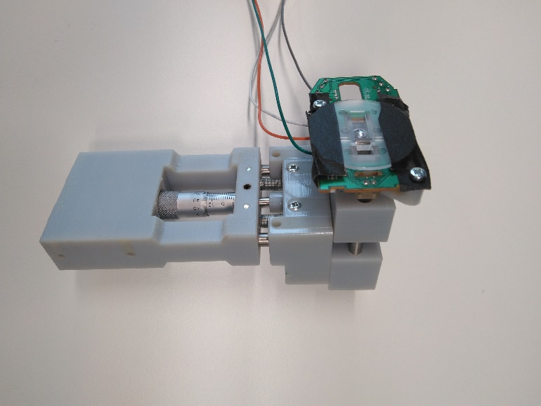
Figure 2: Micrometer structure CAD design (left) and 3D printed model (right).

Assembly instructions
Table 1: Bill of materials (For each sensor).
Component | Quantity | Supplier | Reference
Optical mouse | 1 | - | https://www.ebay.co.uk/itm/HP-PS2-Optical-Mouse-for-Desktops-Laptops-417966-001/272643457275?ssPageName=STRK%3AMEBIDX%3AIT&_trksid=p2060353.m2749.l2649
Mobile part x | 1 | - | 3D printed part
Mobile part y | 1 | - | 3D printed part
Base part x | 1 | - | 3D printed part
Base part y | 1 | - | 3D printed part
Sensor holder | 1 | - | 3D printed part
M2 x 4 mm | 4 | RS Components | 914-1462 RS PRO Pozidriv Pan Head A2 304 Stainless Steel Machine Screw, M2, 4mm
M3 x 8 mm | 8 | RS Components | 908-7481 RS PRO Pozidriv Countersunk Head Bright Zinc Plated Steel Machine Screw, M3, 8mm
M3 x 4 mm | 2 | RS Components | 556-580 RS PRO, M3 Pan Head, 6mm Steel Pozidriv Bright Zinc Plated
M3 x 12 mm | 2 | RS Components | - 528-952 RS PRO, M3 Countersunk Head, 12mm Stainless Steel Pozidriv A2 30
M3 x 20 mm | 12 | RS Components | 560-625 RS PRO Pozidriv Pan Head Bright Zinc Plated Steel Machine Screw, M3, 20mm
M3 x 6 mm | 4 | RS Components | 137-720 RS PRO M3 x 6mm Hex Socket Set Screw Plain Stainless Steel
M4 x 6 mm allen prisoner screw | 2 | RS Components | 529-949 Black, Self-Colour Steel Hex Socket Set M4 x 6mm Grub Screw
Connectivity Male UNC 4-40 Screw Lock for use with D-sub Connector | 4 | RS Components | 717-4505 TE Connectivity Male UNC 4-40 Screw Lock for use with D-sub Connector
Micrometer | 2 | RS Components | 785-7875 Midi Micrometer Head 0-13mm
Metal cilinder 6 mm | 4 | Thorlabs | ER2-P4 - Cage Assembly Rod, 2" Long, Ø6 mm, 4 Pack
Extension spring | 4 | Ebay | TENSION SPRING - 0.5mm WIRE - 20mm (L) x 5mm (OD) - ES017
M6 threaded insert | 1 | RS Components | 664-7359 Böllhoff Galvanised, M6 Steel Threaded Insert Depth 14mm
M3 threaded insert | 4 | RS Components | 278-534 RS PRO, M3 Brass Threaded Insert diameter 4mm Depth 4.78mm

In order to use the mice sensors, the PCB must be removed from the optical mouse and the VDD, GND, SCK and SDIO must be soldered with wires to be connected to the microcontroller with the microcontroller internal 5V power supply.
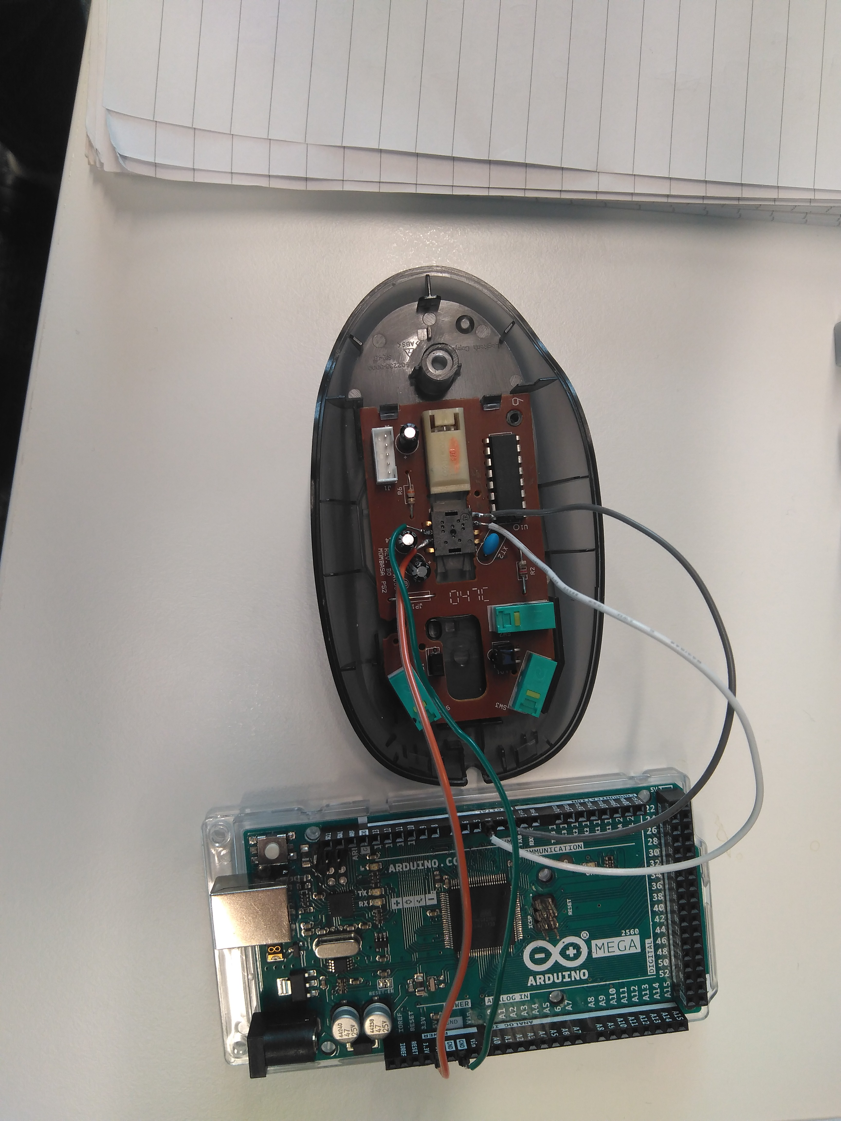
Figure 3: Soldered pins on the ADNS-2610.
The lens must be glued to the PCB in the correct position, with the lens aligned with the optical flow sensor.
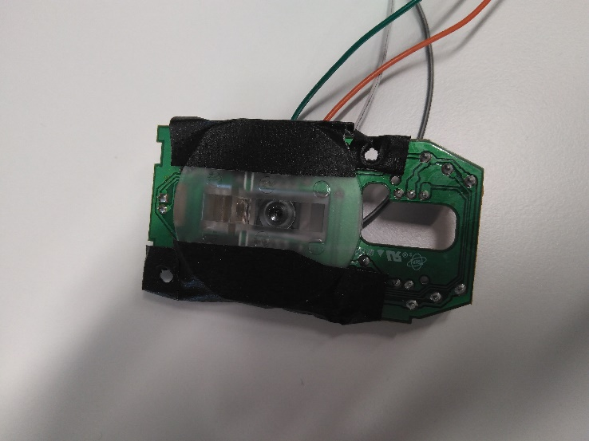
Figure 4: ADNS-2610 glued with the lens.
All the 3D printable parts must be printed, the parts have been designed to be printed optimally with an Objet 30 (Polyjet resin printer), also have been printed with a Form 2 (SLS resin printer). The materials used are the Vero gray resin and the Clear V4 resin with the Objet 30 and the Form 2 respectively. For both printers the settings have been the default settings.
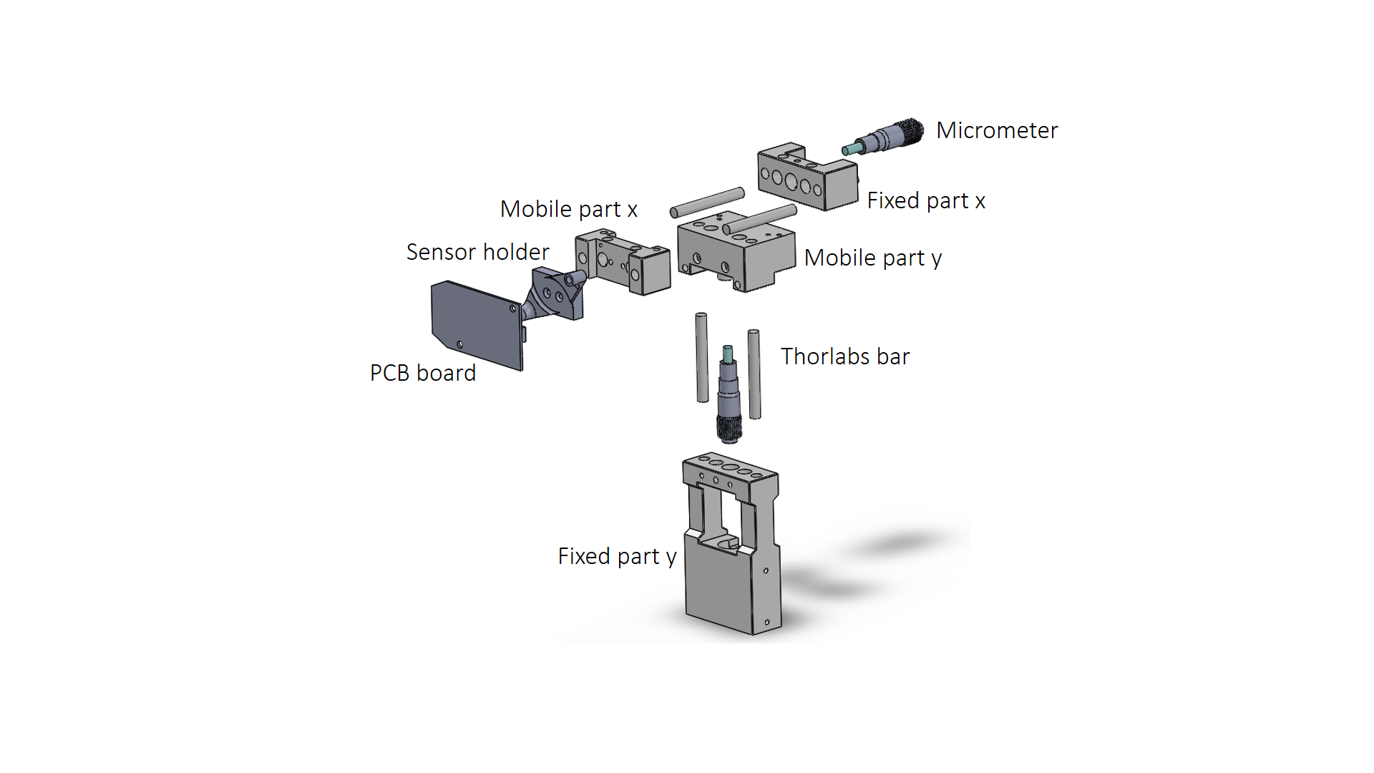
Figure 5: Main components of the assembly.
Once you have the 3D printed parts, put the M3 threaded inserts on the Mobile part x and Mobile part y. These threads have been created to block the system once the desired position is achieved.
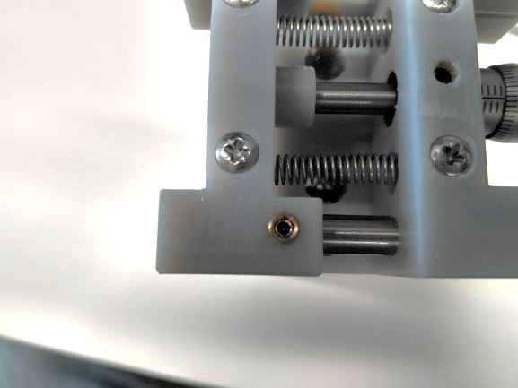
Figure 6: Threaded inserts on the 3D printed parts.
Insert two M3 threaded inserts on the sensor holder holes.
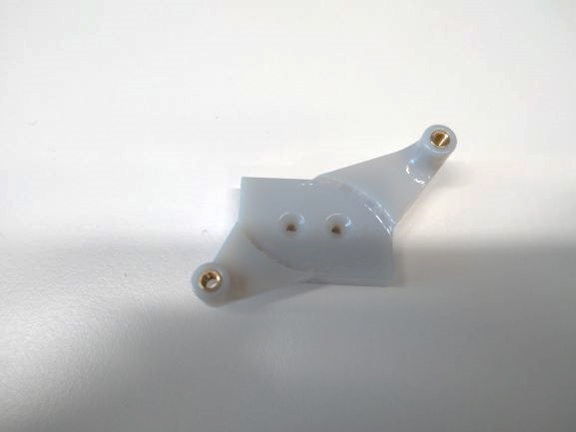
Figure 7: Threaded inserts on the sensor holder part.
Insert the M6 threaded insert on the bottom of the Fixed part y.
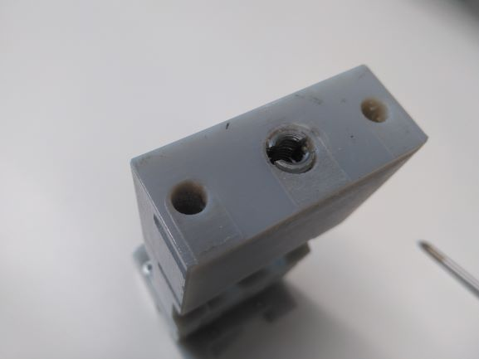
Figure 8: M6 threaded insert on the Fixed part y.
Insert the Thorlabs® bars on the Fixed part y and Fixed part x and use the Connectivity Male UNC 4-40 Screw to hold these bars.
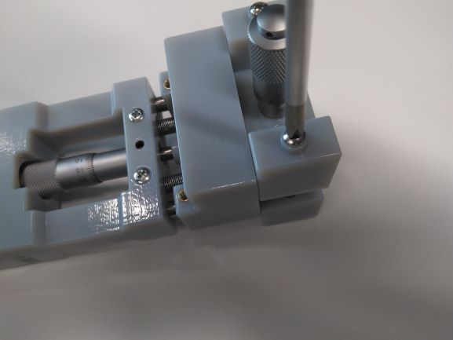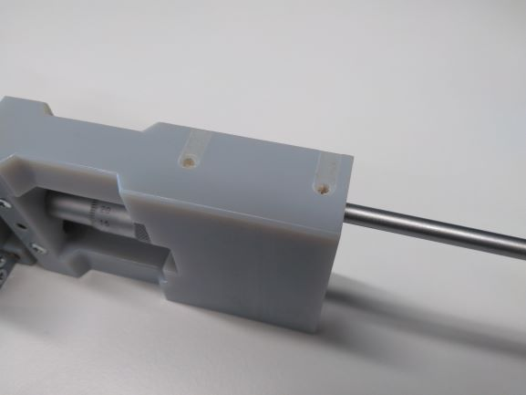
Figure 9: The connectivity male UNC 4-40 screwed with the Thorlabs bar thread.
Insert the two M4 Allen screw on the Fixed part x and y.
Insert the M3 x 20 mm screw and attach the extension springs on the Fixed part x and y. Use a tweezers to connect the two stages, the Fixed part and the mobile part for both stages inserting other M3 x 20 mm screws on the other stage.

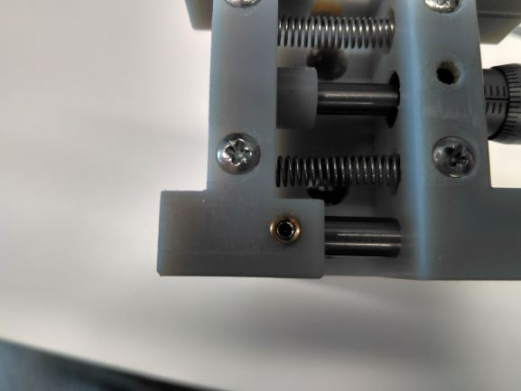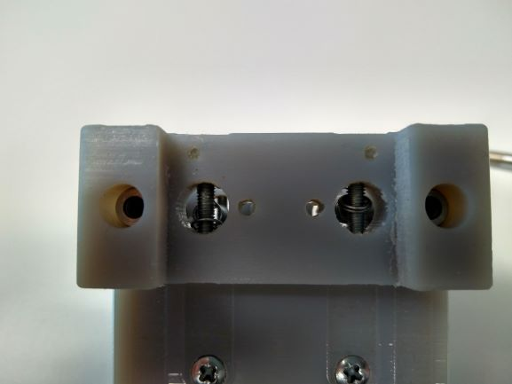
Figure 10: Extension springs attached between the mobile and the fixed part with the M3 20 mm screws.
Attach the micrometers using the M4 screw to make pressure with the circular hole.
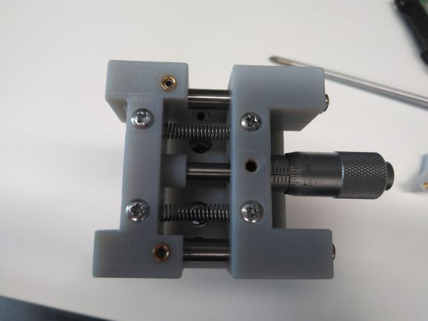
Figure 11: M4 screw holding the Micrometer.
Insert the four M3 x 20 mm screws to connect both stages (vertical and horizontal).
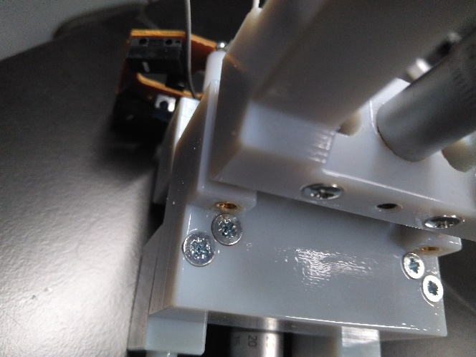
Figure 12: M3 x 20 mm screws to connect both stages.

Screw the sensor holder to the Mobile part x.
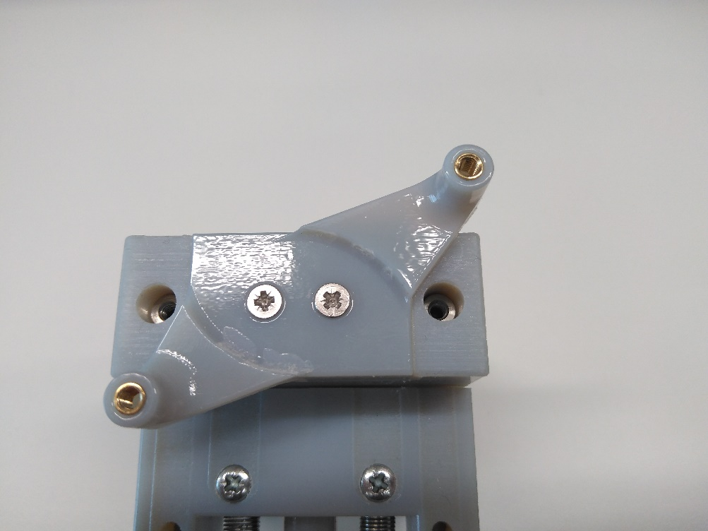
Figure 13: M4 screw holding the Micrometer.
Attach the sensor on the sensor holder.
Connect the pins on the Arduino 5V, GND, and two digital pins.
Download the library, this one was created by Martijn and modified by Zapmaker [3] and can be found in their repository.

Calibration
The calibration can be done adjusting the vertical position on the making coincident the equator of the sphere with the optical flow sensor.
Then the horizontal position can be achieved by adjusting the horizontal micrometer until a SQUAL value of more than 100 has been achieved.
The error in percentage of the distance measurement while spinning the ball manually with a certain initial SQUAL value increases when the initial SQUAL value decreases in the way of the Figure 14:

Figure 14: Relationship between the initial SQUAL value and the measured distance in one revolution.
Recording the ball spinning with pressured air injected (experiment conditions) during ten seconds the number of samples with a certain error can be estimated (Figures 15 and 16).

Figure 15: SQUAL value during a recording of 10 seconds at 1000 Hz spinning the ball with pressured air.

Figure 16: Relationship of the SQUAL value and the number of samples recorded in 10 seconds at 1000 Hz.

Some conclusions after these recordings are:
- The average of the SQUAL value is 85.4.
- 85.1 % of the samples have a SQUAL value of 60 or more (error < 5.56%).
- 94.6 % of the samples have a SQUAL value of 40 or more (error < 10.22%).
- 98 % of the samples have a SQUAL value of 20 or more (error < 39.41%).

References

[1] | "https://media.digikey.com/pdf/Data%20Sheets/Avago%20PDFs/ADNS-2610.pdf," [Online].
[2] | "https://www.ebay.co.uk/itm/HP-PS2-Optical-Mouse-for-Desktops-Laptops-417966-001/272643457275?ssPageName=STRK%3AMEBIDX%3AIT&_trksid=p2060353.m2749.l2649," [Online].
[3] | "https://github.com/zapmaker/OptiMouse," [Online].

